 **National University of Computer & Emerging Sciences, Karachi**

**Department of Computer Sciences**

**Mid-Term Examination (Fall 2019)**

**16 October 2019**

|  |  |
| --- | --- |
| **Course No: CL 118** | **Course Name: Programming Fundamental** |
| **Instructor Name / Names: Atiya Jokhio and Maham Mobin Shaikh** | |
| **Student Roll No:** | **Section: G** |

**Time Allowed**: 90 minutes. **Total Marks**: 30

Instructions:

* Attempt all questions, read each question completely and use your question paper for rough work.
* After completion of exam, return the question paper.
* Your Student ID must be written on the paper.
* In case of any ambiguity, you may make assumption. But your assumption should not contradict any statement in the question paper.
* If any question regarding paper, you may ask within 5 minutes after starting paper.
* For Exam submission: Create a folder named **“your student-id” i.e. (K19-0100).**
* Paste the .c file for each question named as **Q1.c, Q2.c** and on so in that folder.
* Convert the folder into zip.

**Question # 1:** *[ Marks:7 Time:20 mints ]*

Write a program using function that receives month and date of birth as input and prints the corresponding zodiac sign based on the following table:

|  |  |
| --- | --- |
| Sun Sign | From-To |
| Capricorn | Dec 22 – Jan 19 |
| Aquarius | Jan 20 – Feb 17 |
| Pisces | Feb 18 – Mar 19 |
| Aries | Mar 20 – Apr 19 |
| Taurus | Apr 20 – May 20 |
| Gemini | May 21 – Jun 20 |
| Cancer | Jun 21 – Jul 22 |
| Leo | Jul 23 – Aug 22 |
| Virgo | Aug 23 – Sep 22 |
| Libra | Sep 23 – Oct 22 |
| Scorpio | Oct 23 – Nov 21 |
| Sagittarius | Nov 22 – Dec 21 |

**Question # 2:** *[Marks:8 Time:25 mints]*

Let’s play a game of recursion which consists of three rods, and a number of disks of different sizes which can slide onto any rod. The game starts with the disks in a neat stack in ascending order of size on one rod, the smallest at the top. You have to obtain the same stack on the third rod. There are some rules to follow for playing this game.

* Only one disk can be moved at a time.
* Each move consists of taking the upper disk from one of the stacks and placing it on top of another stack i.e. a disk can only be moved if it is the uppermost disk on a stack.
* No disk may be placed on top of a smaller disk.

Hint: Use the variable A, B, C as rods. The output should show the sequence of moving peg from one rod to another which in result should be the same stack on the third rod.

**Question # 3:** *[Marks:7 Time:20 mints]*

**Yasir** is preparing for exams, he is checkingwhether a number is an Armstrong Number or not.

Example 1) => 163  
(1 ^ 3) + (6 ^ 3) + (3 ^ 3) => 1 + 216 + 27 = 244 (Not Armstrong Number)  
  
Example 2) => 153  
(1 ^ 3) + (5 ^ 3) + (3 ^ 3) => 1 + 125 + 27 = 153 (Armstrong Number)

**Question # 4:** *[Marks:8 Time:25 mints ]*

Draw a following pattern using C coding

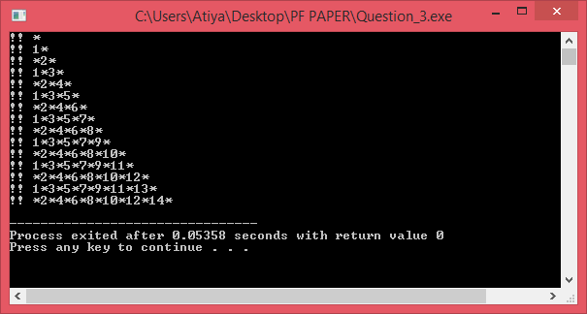

***BEST OF LUCK!***